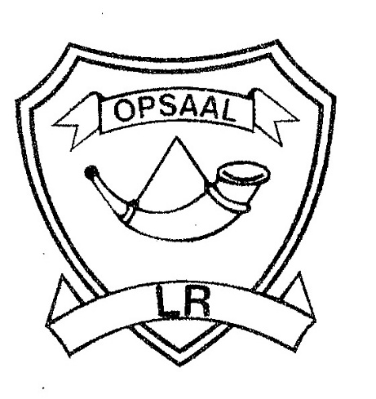
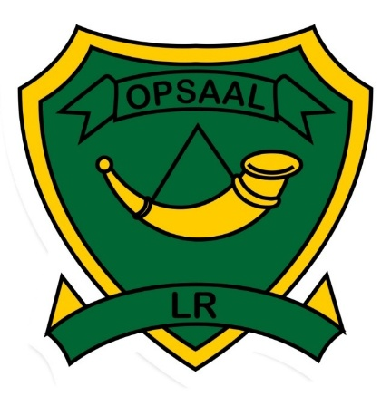
Riviera Primary
School Governing Body

6 Rose Street • Riviera • Pretoria • 0084
Tel: 081 590 4776 or 066 044 5947
E-mail: 230979@intekom.co.za
Website: www.lsriviera.co.za

30 March 2020

PARENT CIRCULAR 04/2020

Dear Parents and Guardians

On Monday, 23 March 2020, The President of South Africa, Mr Cyril Ramaphosa, announced an escalation of measures by declaring a national lockdown to slow down the spread of Covid-19. Do the lockdown for yourself, your family and your own safety. The only thing that can prevent South African infections from growing as exponentially as they have in other countries is social distancing. The next days are critical to flattening the curve and slowing down infections.

So many people complain that they never have enough time – and later wished that they made more time for all the really important things in their live.
Time is the only commodity that we will never get back. Money, health and love may be things that we can experience again.

Make the most of your current situation and enjoy the time with your family. Use all your available time to do chores in and around the house and to strengthen your family relationships.

When we experience a lockdown like this we tend to welcome and appreciate all the little freedoms that we previously took for granted.

In stressing times like these we all need a reason to smile. It is very common feeling to feel overpowered and frightened by all the waves of the Coronavirus news.

Regardless of the present conditions, Riviera Primary encourages our community to discover ways to remain engaged and satisfied both physically and intellectually. Think outside the box and do things that you haven’t done in a while.

The SGB and SMT of Riviera Primary will keep parents and community informed regarding the latest developments and information concerning Covid19.

May every parent, learner and staff member be safe during these trying times.

We wish you all the best.

Regards
SGB and SMT

Benjamin Franklin Quote: One today is worth two tomorrows

